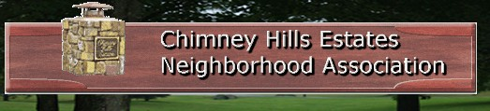

August 2026

Notes from the President of the HOA:

School has started so please be aware of the children coming and going from Darnaby Elementary, especially outside the school and at the school bus stops in the neighborhood.

The Tulsa County Clerk’s office has a free service called RecordRadar. If you register on their site, you will be notified when any documents such as liens or deed transfers are filed against your property. If you are interested, go to: countyclerk.tulsacounty.org/Home/RecordRadar

The HOA Board is always looking for ideas to improve our neighborhood. If you have any ideas or suggestions, please let the Board know either at the board meetings or through our website. The next board meeting is Aug. 25th.

If you have any questions or concerns, go to our website and fill out the contact form. We try to respond in a timely manner. https://www.chimneyhillsestates.com/

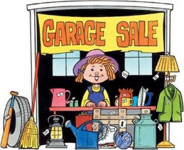
Garage Sale September 12th!

The Chimney Hills Fall Neighborhood Garage Sale will be held Sept. 12th. Signs will be posted at the main entrances a few days before. While the “official” sale is Saturday, residents are welcome to start on Friday if they have lots to sell. It’s also good practice to put out your own signs directing traffic to your block, especially if you live deep in the neighborhood.
Support Darnaby with Classroom Supplies
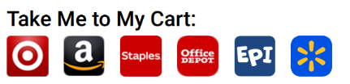
Union Schools offers a new feature that allows supporters a chance to donate classroom supplies. Parents, grandparents and neighborhood friends can pick a child’s school, select a grade and choose from a range of retailers. They can also download a shopping list that includes age appropriate items that cover just about everything a teacher, or child, might find useful in a classroom. “We wanted to provide another option for busy parents and guardians who would like to save a trip to the store for school supplies,” said Chris Payne, chief communications officer for Union Public Schools.
Details on the program and a link to the shopping lists can be found here: https://darnaby.unionps.org/students/enrollment/school-supplies

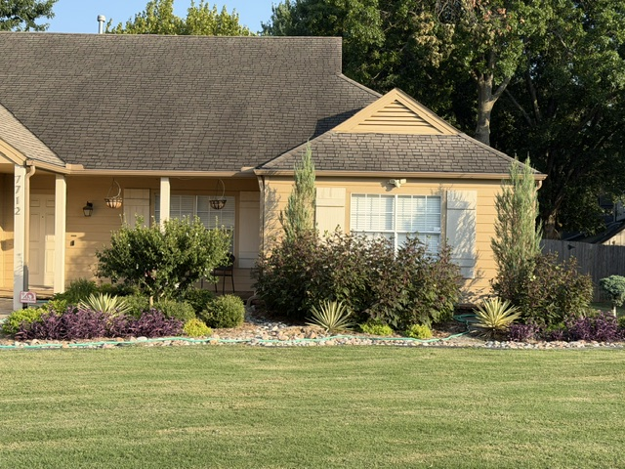
July 2026 Yard of the Month: The owner at 7712 E 87th St. had their walkways and landscaping updated and the shrubbery and plantings are looking great. Congratulations on being selected as the neighborhood’s Yard of the Month for July!
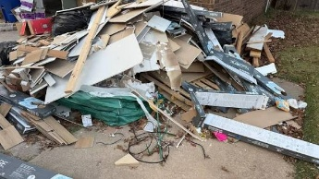
Tulsa Bulk Waste Pickup
The City of Tulsa provides bulk waste collection for large items that do not fit inside your refuse cart, and for yard waste that is too big to bundle for the regular hauler. There is a current fee of $10 per 8 cubic yards, which is the size of a small car. Sample items include large appliances, furniture and mattresses, and large yard waste such as trees and stumps less than 5 feet long. Cost for this service will jump to $20 on Oct. 1.
For additional information and to schedule a collection visit: https://www.cityoftulsa.org/bulkywaste.
Extra Waste That Doesn’t Fit the Can
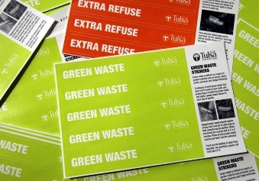
To dispose of trash that does not fit inside your refuse cart, but not large enough to require a bulk waste pickup, bag the trash and apply an “Extra Refuse” sticker to each bag. Bags must not exceed 40 pounds in weight. Extra Refuse stickers cost $2 each and may be purchased at any area QT location in Tulsa. For yard waste, if it can be tied into bundles that are 4' by 2', or placed in see-through bags, it can be put out for the regular refuse hauler at no cost. There is a maximum of 15 extra bags and/or bundles each week.

